WEEK-3
Create a Spring Web Project using Maven
1. Project Overview
- 1.1 Introduction: Brief description of the project and its objective as a foundational Spring Boot web application.
- 1.2 Technology Stack: Listing the core tools used (Java, Spring Boot, Maven, IntelliJ IDEA).
2. Project Initialization & Configuration
- 2.1 Spring Initializr Setup: Documentation of the project metadata (Group: com.cognizant, Artifact: spring-learn, Package: com.cognizant.springlearn).
- 2.2 IDE Import Process: Steps taken to generate and load the project inside IntelliJ IDEA.
3. Build and Execution Guide
- 3.1 Maven Build Lifecycle: Explanation of packaging the application.
- 3.2 Network Proxy Configuration: The specific Maven command used to build the project behind the corporate firewall (-Dhttp.proxyHost, etc.).
- 3.3 Running the Application: Instructions on executing the main method and verifying the embedded Tomcat server startup.
4. Directory Structure
- 4.1 src/main/java: Purpose of the main source folder and package organization.
- 4.2 src/main/resources: Purpose of the resources folder (e.g., application.properties and static assets).
- 4.3 src/test/java: Overview of the testing directory for unit and integration tests.
5. Core Components Analysis
- 5.1 Application Entry Point: Breakdown of the SpringLearnApplication.java class and the main() method.
- 5.2 The @SpringBootApplication Annotation: Explanation of its underlying components (@EnableAutoConfiguration, @ComponentScan, @SpringBootConfiguration).
- 5.3 Logging Implementation: How SLF4J was integrated to output custom initialization messages upon successful startup.
6. Dependency Management
- 6.1 The pom.xml File: Overview of the Project Object Model, parent inheritance, and metadata.
- 6.2 Core Dependencies: * spring-boot-starter-web: For RESTful routing and embedded Apache Tomcat.
  - spring-boot-devtools: For hot-reloading and faster development cycles.
- 6.3 Dependency Hierarchy: Explanation of how Maven resolves transitive (nested) dependencies and how to visualize the tree in IntelliJ.
src/main/java/com/cognizant/springlearn/SpringLearnApplication.java
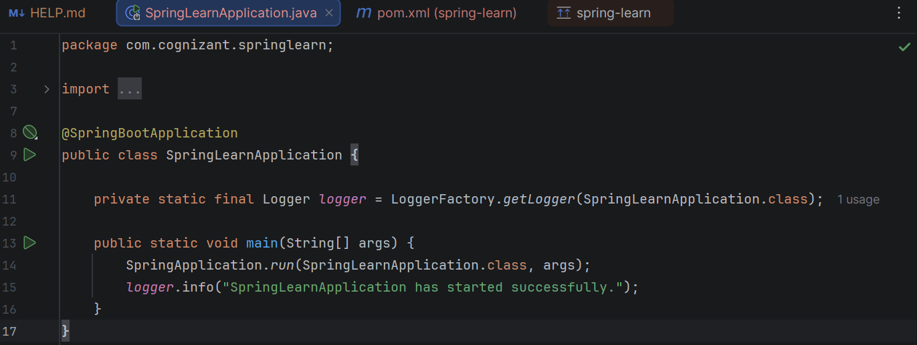
Execution Result :

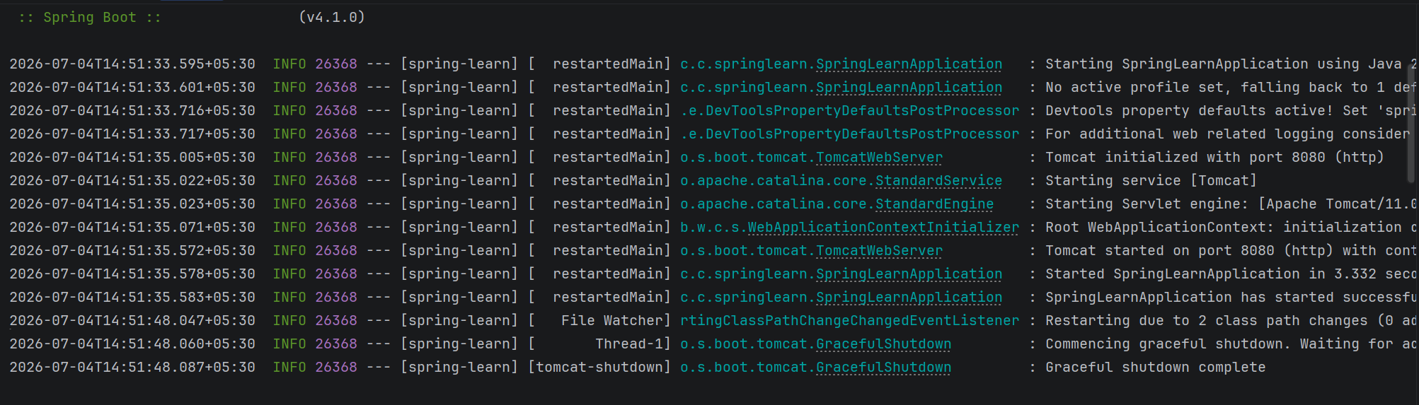

Dependency Tree:
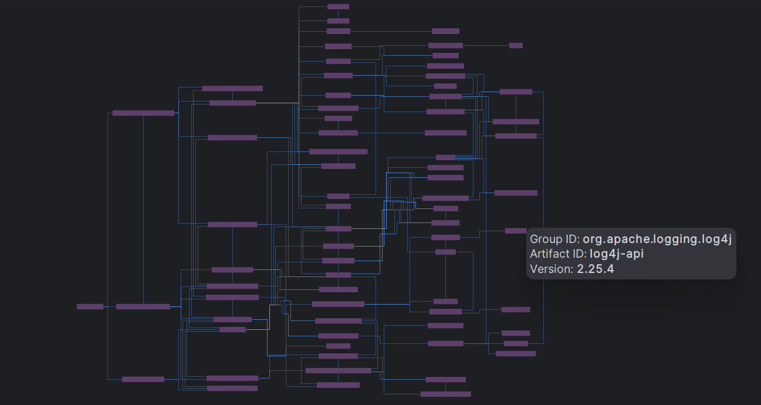

Spring Core - Load Country from XML
1. Project Overview
- 1.1 Objective: To demonstrate the fundamentals of the Spring Inversion of Control (IoC) container by externalizing object data into an XML configuration file and injecting it into a Java POJO (Plain Old Java Object).
- 1.2 Use Case: An airline website requiring a configurable list of supported countries, storing both the two-character ISO code and the full country name.
2. Configuration details
- 2.1 XML Configuration (country.xml):
  - Located in src/main/resources.
  - Utilizes the Spring beans schema to define the data.
  - Contains a <bean> definition for India (Code: IN, Name: India).
- 2.2 Logging Configuration:
  - application.properties updated with logging.level.com.cognizant=DEBUG to expose constructor and setter injection lifecycle events.
3. Implementation Components
- 3.1 Country.java (Model/POJO):
  - Contains private instance variables code and name.
  - Includes a default, no-argument constructor with an SLF4J debug log.
  - Implements getter and setter methods, each instrumented with debug logs to track execution.
  - Overrides the toString() method for clean data representation.
- 3.2 SpringLearnApplication.java (Main Application):
  - Implements a displayCountry() method.
  - Initializes the Spring IoC container using ClassPathXmlApplicationContext.
  - Retrieves the bean and logs the fully populated object.
4. Execution and Lifecycle Verification
- 4.1 Expected Output Sequence:
  - Inside Country Constructor.
  - Inside setCode method.
  - Inside setName method.
  - Country : Country{code='IN', name='India'}
- 4.2 Lifecycle Analysis: The logs successfully verify that Spring first creates the object using the default constructor, and subsequently uses setter injection to populate the properties defined in the XML.
5. Core Spring Concepts (SME Walkthrough)
- 5.1 XML Tags and Attributes:
  - <bean>: Instructs the IoC container to manage a specific object.
  - id: The unique identifier used to retrieve the bean ("country").
  - class: The fully qualified path of the Java class.
  - <property>: Triggers setter-based dependency injection.
  - name / value: The instance variable to set and the data to inject into it, respectively.
- 5.2 Application Context:
  - ApplicationContext: The core interface representing the Spring IoC container, responsible for bean lifecycle management.
  - ClassPathXmlApplicationContext: An implementation that loads configuration metadata specifically from XML files located on the application's classpath.
- 5.3 Bean Retrieval (getBean):
  - Invoking context.getBean("country", Country.class) queries the Spring registry for the specified id, validates that the object matches the Country class type, and returns the fully assembled, ready-to-use Singleton instance.

country.xml
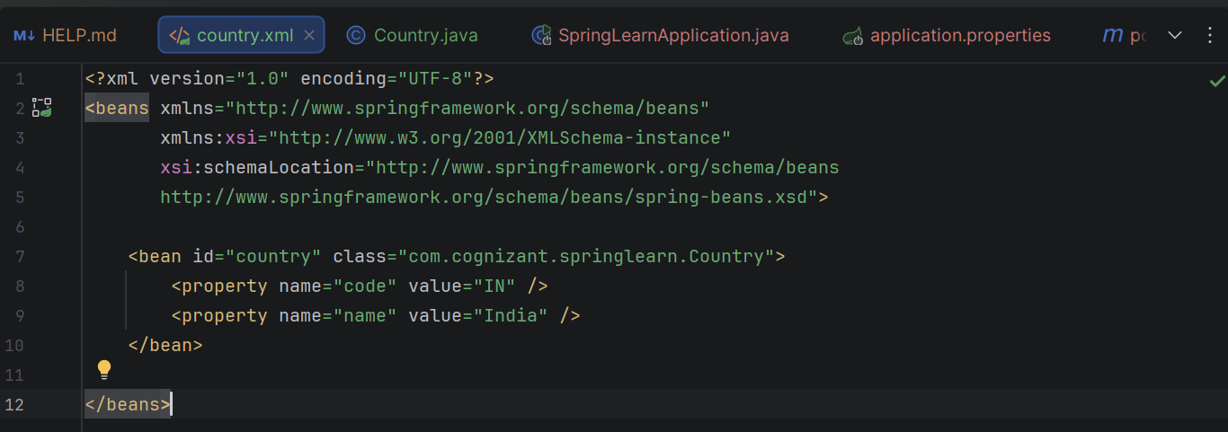
src/main/java/com/cognizant/springlearn
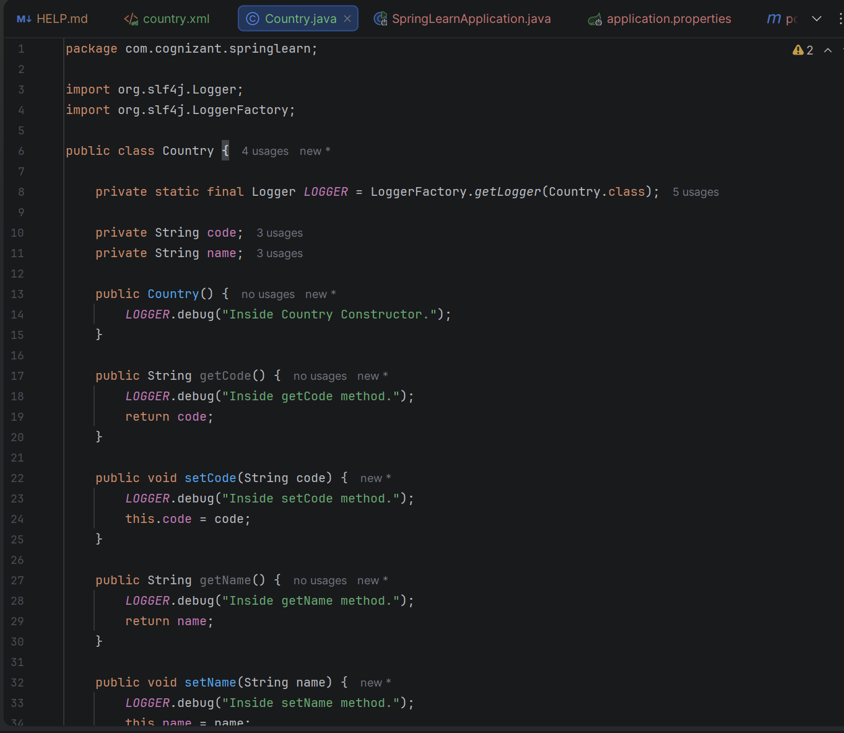
SpringLearnApplication.java
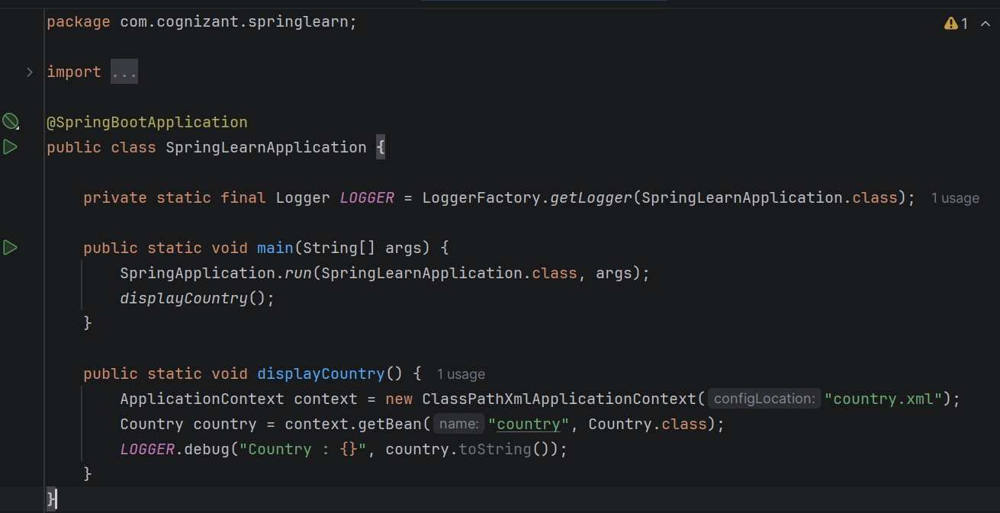

Execution Result:
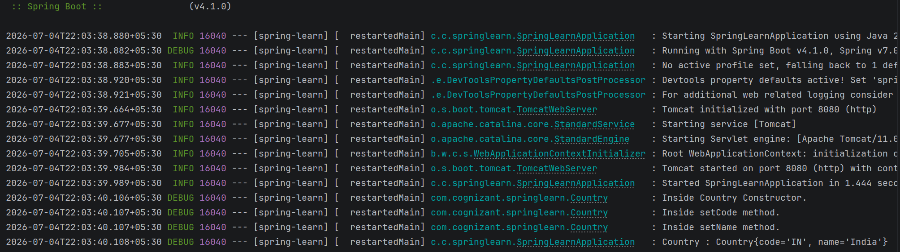

Hello World RESTful Web Service
1. Project Overview
- 1.1 Objective: To expose a basic HTTP GET endpoint using the Spring Web MVC framework within the existing Spring Boot application.
- 1.2 Use Case: Validating that the embedded web server handles incoming web requests, routes them to the correct controller method, and returns a hardcoded string response to the client.
2. Configuration Details
- 2.1 Server Port Customization:
  - File: src/main/resources/application.properties
  - Configuration: server.port=8083
  - Purpose: Overrides the default embedded Tomcat port (8080) to avoid port conflicts and fulfill project requirements.
3. Implementation Components
- 3.1 The REST Controller (HelloController.java):
  - Location: com.cognizant.springlearn.controller package.
  - Class-level Annotation: @RestController is used to mark the class as a request handler and ensure the return value is bound directly to the web response body.
  - Method Implementation:
    - Signature: public String sayHello()
    - Routing: Mapped to the /hello URI using the @GetMapping("/hello") annotation.
    - Logic: Returns the exact string "Hello World!!".
- 3.2 Logging Integration:
  - Utilized LoggerFactory to capture request lifecycles.
  - Emits [INFO] level logs for "START" at the beginning of the method and "END" right before returning the response.
4. Execution and Testing
- 4.1 Request Details:
  - Method: GET
  - URL: http://localhost:8083/hello
- 4.2 Expected Response:
  - Body: Hello World!!
  - Console Output: Upon invocation, the console successfully logs the START and END messages, proving the method logic was executed.
5. HTTP Header Analysis (SME Walkthrough)
- 5.1 Chrome Developer Tools (Network Tab):
  - Intercepts the browser's raw network traffic.
  - The Headers panel reveals the Request URL, a HTTP Status Code of 200 OK, and Response Headers like Content-Type: text/plain;charset=UTF-8 and Content-Length, demonstrating how Spring automatically formats the raw string response into a valid HTTP payload.
- 5.2 Postman (Headers Tab):
  - Provides a developer-friendly interface to test API endpoints.
  - Beyond showing the response body, the dedicated Headers tab parses the metadata sent by Tomcat, validating that the server properly identified the data type and payload size.
src/main/resources/application.properties
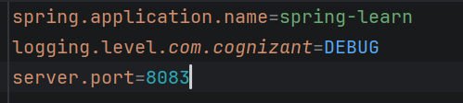
com.cognizant.springlearn.controller
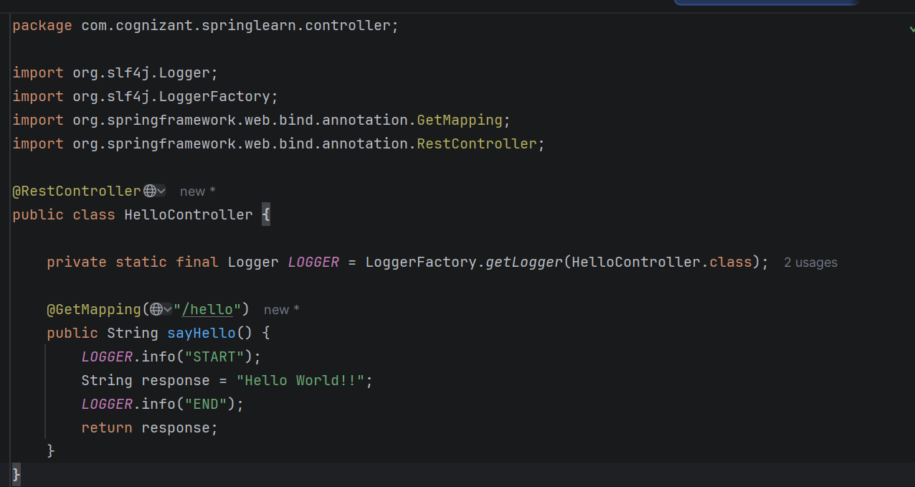

Execution Result:
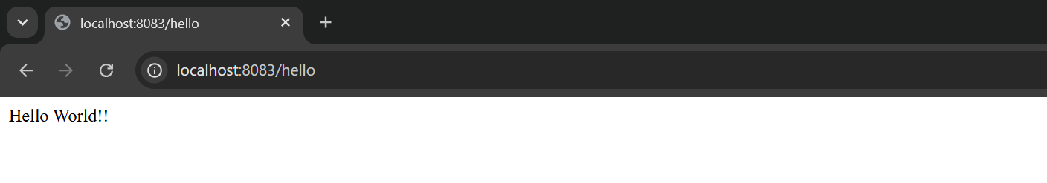
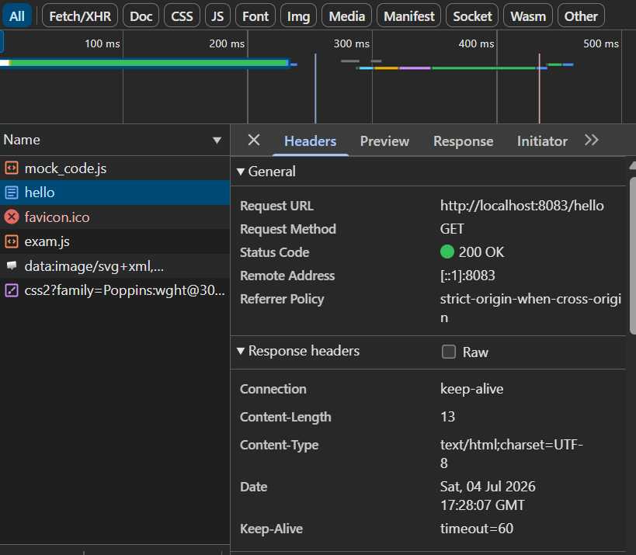
REST - Country Web Service
1. Project Overview
- 1.1 Objective: To expose a RESTful web service endpoint that retrieves data from a Spring XML configuration and returns it as a JSON payload to the client.
- 1.2 Use Case: Providing consumer applications with structured data for the country India (including its ISO code and name) using standard HTTP GET requests.
2. Implementation Components
- 2.1 The REST Controller (CountryController.java):
  - Location: com.cognizant.springlearn.controller package.
  - Class-level Annotation: Annotated with @RestController to combine @Controller and @ResponseBody, ensuring the return value is automatically serialized into the HTTP response body.
  - Method Implementation:
    - Signature: public Country getCountryIndia()
    - Routing: Mapped to the /country endpoint via @RequestMapping(value = "/country", method = RequestMethod.GET).
    - Logic: Instantiates a ClassPathXmlApplicationContext to read country.xml, retrieves the populated Country bean using context.getBean(), and returns the Java object.
3. Execution and Testing
- 3.1 Request Details:
  - Method: GET
  - URL: http://localhost:8083/country
- 3.2 Expected Response:
  - The server returns the following structured JSON payload:
JSON
{
"code": "IN",
"name": "India"
}
4. Core Mechanics & Header Analysis (SME Walkthrough)
- 4.1 Controller Workflow:
  - The @RequestMapping intercepts the GET request to /country.
  - The Spring Inversion of Control (IoC) container is manually initialized inside the method.
  - The container reads the XML, performs dependency injection to populate the properties of the Country object, and hands it back to the controller method.
- 4.2 JSON Serialization:
  - The conversion from a Java Object to JSON is handled seamlessly by Spring Web's default integration with the Jackson library.
  - Because the class uses @RestController, the returned Country object is passed to Jackson's ObjectMapper, which reads the getters (getCode(), getName()) and formats the output as a standard JSON string.
- 4.3 Network Inspection (Chrome Developer Tools & Postman):
  - Intercepting the HTTP traffic in either the Chrome Network tab or the Postman Headers tab reveals a critical metadata change.
  - The Response Headers now clearly indicate Content-Type: application/json. This header dynamically informs the client application (or browser) that the incoming payload is structured JSON data rather than plain text.

src/main/java/com/cognizant/springlearn/controller
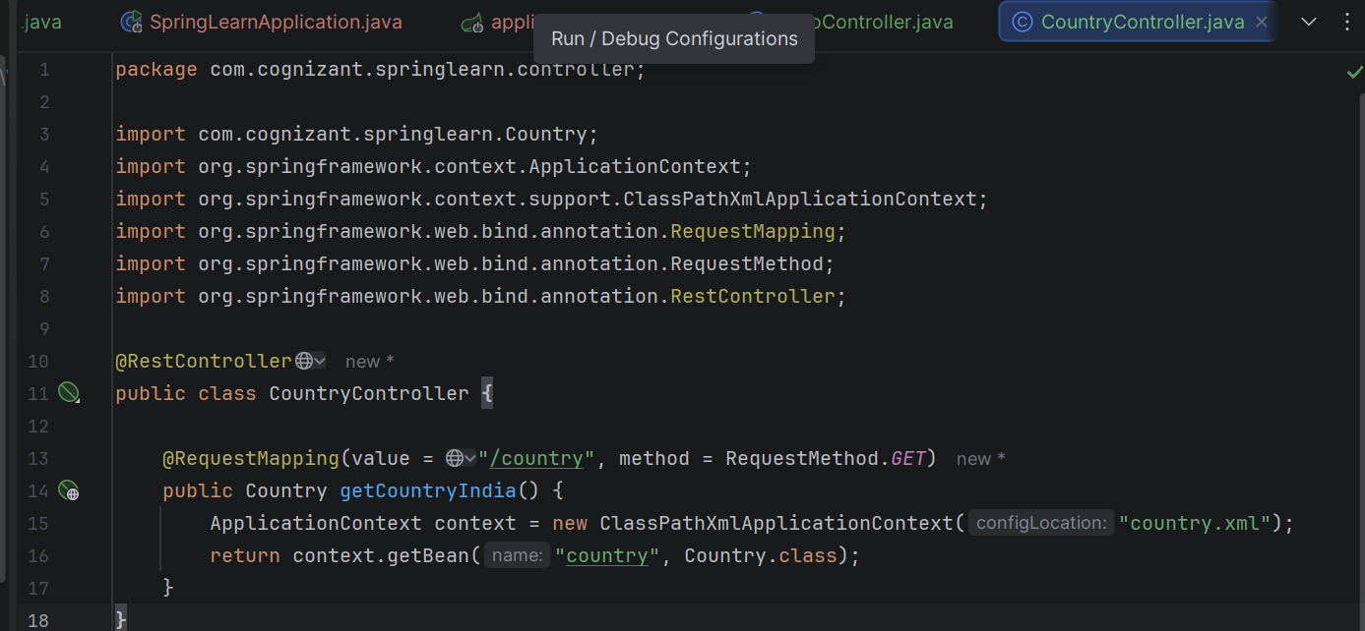

Execution Result:
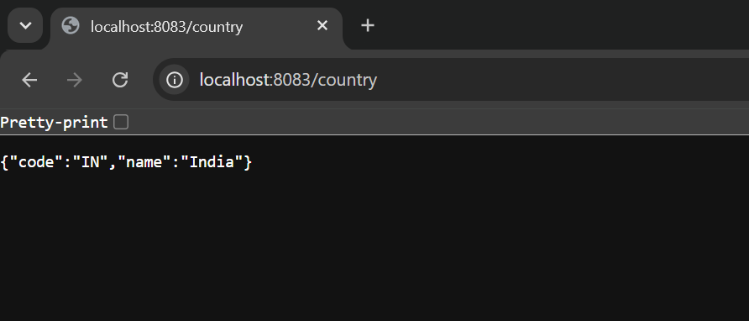

REST - Get Country by Code
1. Project Overview
- 1.1 Objective: To enhance the existing Spring Boot application by exposing a dynamic REST endpoint that retrieves specific country details based on a user-provided, case-insensitive country code.
- 1.2 Use Case: Allowing external clients to query a master list of countries using standard ISO codes via a URL path variable.
2. Configuration Updates
- 2.1 XML Configuration (country.xml): * Introduced a new Spring bean (id="countryList") of type java.util.ArrayList to hold a collection of multiple Country objects (US, DE, IN, JP).
  - Critical Fix: Maintained the original single <bean id="country"> in the XML file to ensure backward compatibility with the displayCountry() startup method, preventing a NoSuchBeanDefinitionException during application context initialization.
3. Implementation Components
- 3.1 The Service Layer (CountryService.java):
  - Location: com.cognizant.springlearn.service package.
  - Annotation: Marked with @Service to denote business logic.
  - Logic: Instantiates the application context to retrieve the countryList bean. Utilizes Java 8 Stream API and Lambda expressions (.filter(country -> country.getCode().equalsIgnoreCase(code))) to efficiently perform a case-insensitive search and return the matched Country object.
- 3.2 The REST Controller (CountryController.java):
  - Dependency Injection: Utilizes @Autowired to inject the CountryService instance.
  - Method Signature: public Country getCountry(@PathVariable String code)
  - Routing: Mapped to the /countries/{code} endpoint using @GetMapping.
  - Logic: Extracts the dynamic code from the URL path using @PathVariable and delegates the lookup task to the CountryService.
4. Execution and Testing
- 4.1 Request Details:
  - Method: GET
  - URL: http://localhost:8083/countries/in (or /DE, /us)
- 4.2 Expected Response:
  - The server successfully parses the lowercase "in", matches it with "IN", and returns the following JSON payload:
JSON
{
"code": "IN",
"name": "India"
}
5. Core Mechanics (SME Walkthrough)
- 5.1 @PathVariable Extraction:
  - This annotation allows the controller to capture dynamic segments of the URI (the {code} part) and bind them directly to the method parameter, making the REST API flexible and resource-oriented.
- 5.2 Separation of Concerns (Controller vs. Service):
  - This project introduces the Service Layer pattern. The CountryController is now strictly responsible for handling HTTP web requests and routing, while the CountryService handles the heavy lifting of data retrieval and business logic (filtering).
- 5.3 Collection Injection in Spring:
  - The XML configuration demonstrates how Spring can manage and inject entire Collections (like ArrayList) using the <list> and <constructor-arg> tags, rather than just primitive values or single object references.
src/main/resources/country.xml
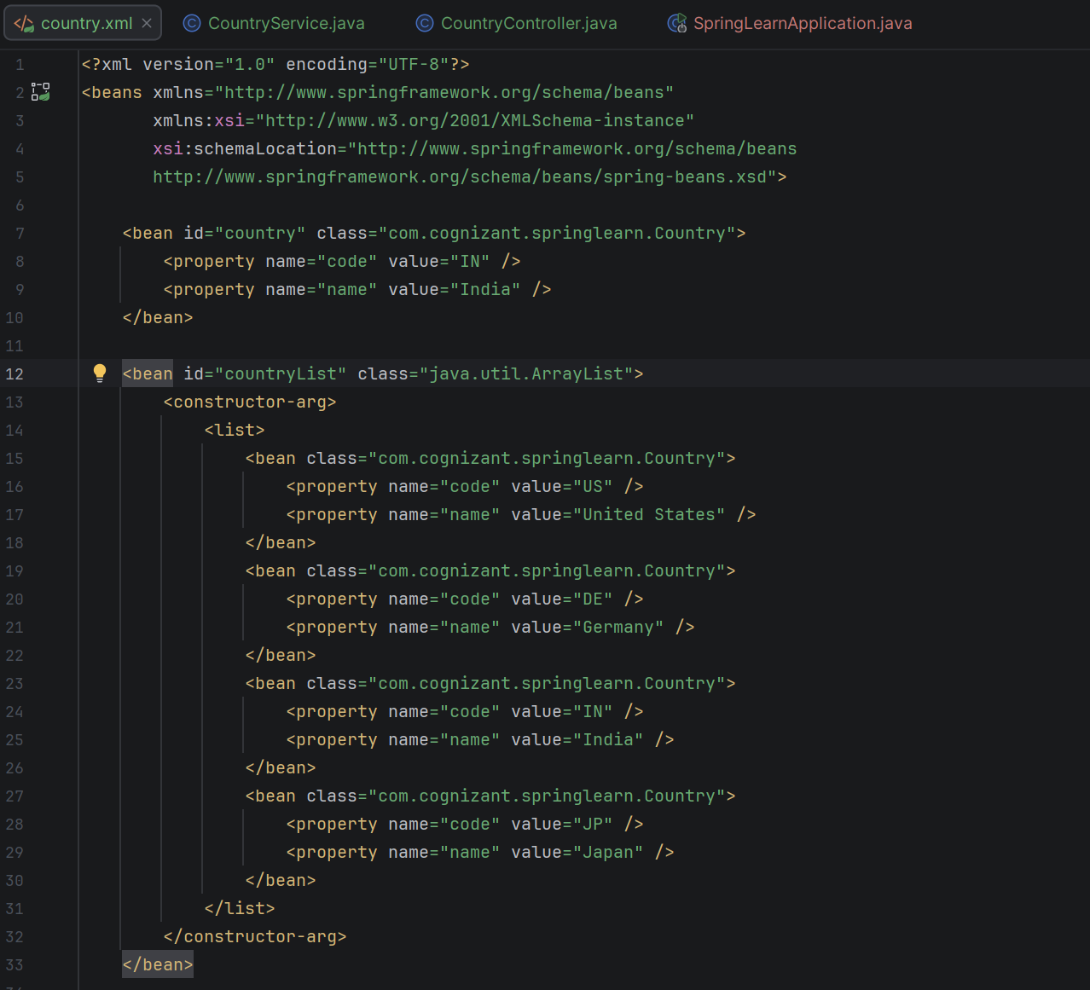

CountryService
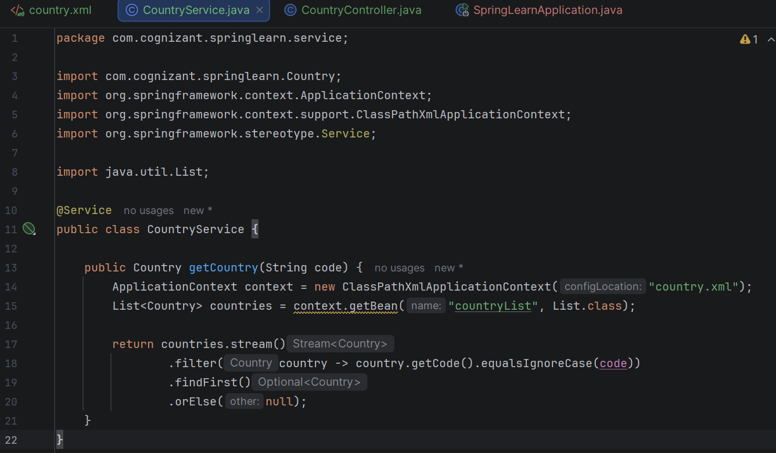
CountryController.java
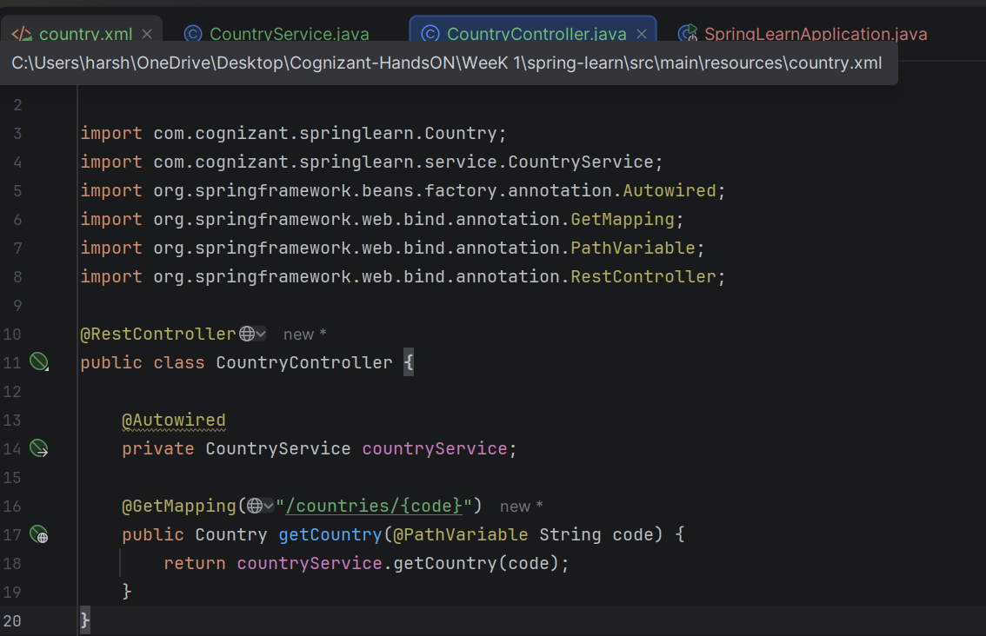
Execution Result :
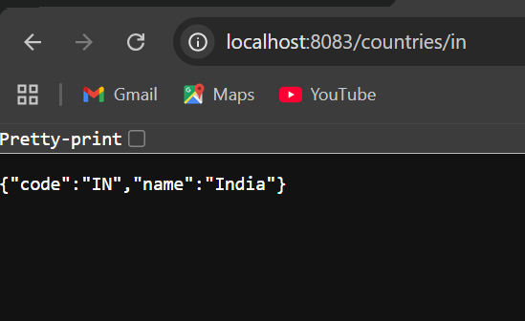

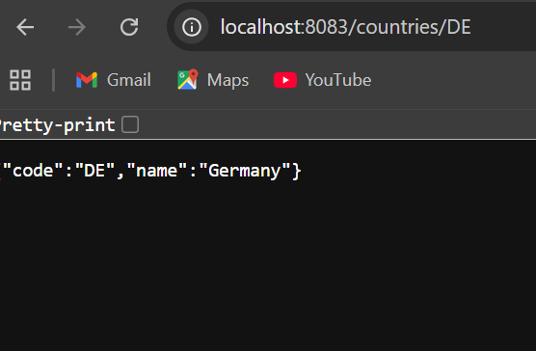

JWT Authentication Service
1. Project Overview
- 1.1 Objective: To build a standalone authentication service using Spring Security that validates user credentials via Basic Authentication and issues a JSON Web Token (JWT) for subsequent stateless authorization.
- 1.2 Use Case: Serving as the gateway for secure API access. Clients exchange their username and password for a temporary token, which they will use to access secured endpoints in future requests.
2. Configuration and Dependencies
- 2.1 Dependencies (pom.xml): * Added jjwt (Java JWT) for token creation and cryptographic signing.
  - Added jaxb-api to ensure XML/Base64 binding compatibility across different Java versions.
- 2.2 Server Configuration:
  - File: application.properties
  - Configuration: server.port=8090 to avoid conflicts with default configurations.
3. Implementation Components
- 3.1 Security Configuration (SecurityConfig.java):
  - Location: com.cognizant.jwtauth.security
  - Logic: Implements a SecurityFilterChain that explicitly disables CSRF (standard for stateless REST APIs), grants unauthenticated public access (.permitAll()) to the /authenticate endpoint, and secures all other incoming requests.
- 3.2 The Controller (AuthenticationController.java):
  - Location: com.cognizant.jwtauth.controller
  - Header Extraction: Uses @RequestHeader("Authorization") to capture the incoming HTTP Basic Auth header.
  - Decoding Logic: Strips the "Basic " prefix and decodes the standard Base64 string to extract the raw username:password payload.
  - JWT Generation: Utilizes the Jwts.builder() to construct a token containing the subject (username), issuedAt timestamp, expiration timestamp (1 hour), and cryptographically signs it using the HS256 algorithm and a hardcoded secret key.
4. Execution and Testing
- 4.1 Request Details:
  - Method: GET
  - URL: http://localhost:8090/authenticate
  - Header: Authorization: Basic dXNlcjpwd2Q= (which is the Base64 encoded string for user:pwd).
- 4.2 Expected Response:
  - The server returns a 200 OK status with the generated token inside a JSON payload:
JSON
{
"token": "eyJhbGciOiJIUzI1NiJ9.eyJzdWIiOiJ1c2VyIiwiaWF0Ijox..."
}
5. Core Mechanics & Troubleshooting (SME Walkthrough)
- 5.1 Basic Auth over Network: When using curl -u user:pwd or Postman's Basic Auth tab, the client automatically concatenates the credentials and encodes them into Base64 before attaching them to the Authorization header. Browsers do not do this automatically when simply typing a URL, which is why a dedicated HTTP client is required.
- 5.2 The 401 Unauthorized Error: If the Authorization header is missing, malformed, or lacks the exact syntax expected by the @RequestHeader, Spring MVC throws an exception. Because the internal /error routing page is not explicitly permitted in the SecurityConfig, Spring Security steps in and blocks the user with a 401 Unauthorized status.
- 5.3 The Default Login Page: If a browser hits a secured endpoint without headers, Spring Security's default behavior is to redirect the user to an auto-generated HTML login form. REST APIs bypass this by utilizing direct header manipulation

pom.xml
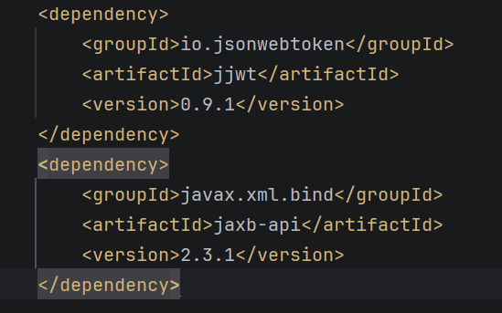
SecurityConfig
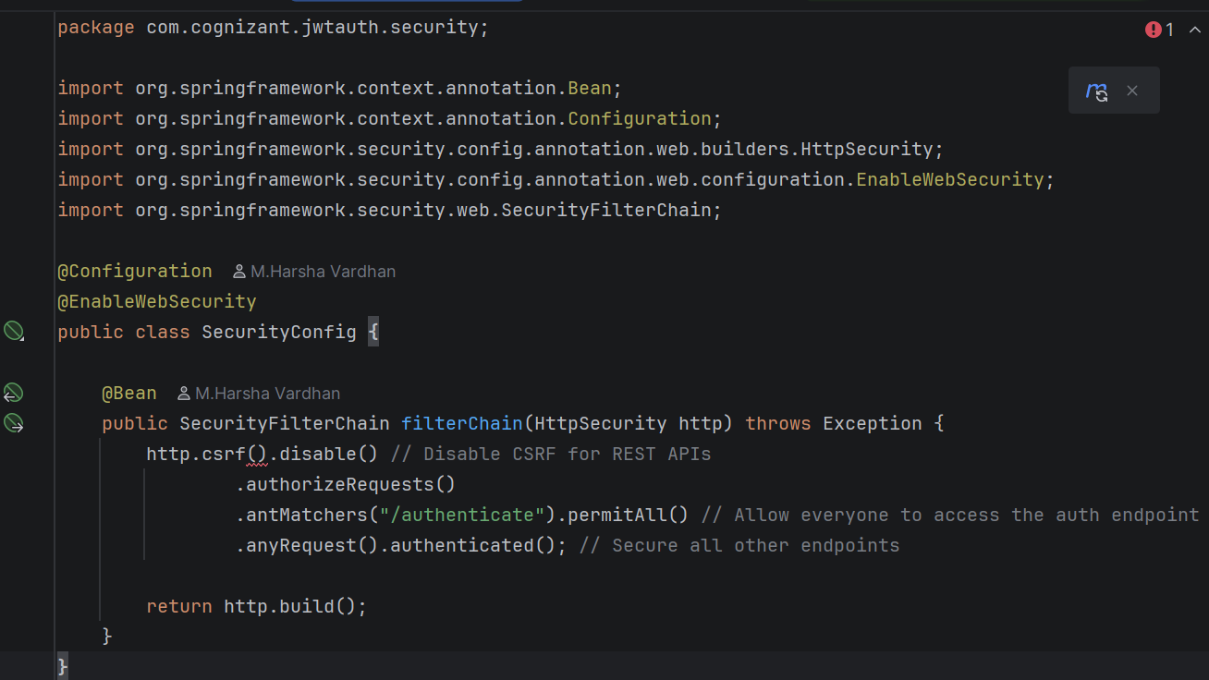
AuthenticationController
package com.cognizant.jwtauth.controller;
import io.jsonwebtoken.Jwts;
import io.jsonwebtoken.SignatureAlgorithm;
import org.springframework.web.bind.annotation.GetMapping;
import org.springframework.web.bind.annotation.RequestHeader;
import org.springframework.web.bind.annotation.RestController;
import java.nio.charset.StandardCharsets;
import java.util.Base64;
import java.util.Date;
import java.util.HashMap;
import java.util.Map;
@RestController
public class AuthenticationController {
private static final String SECRET_KEY = "cognizant-secret-key-for-jwt-generation";
@GetMapping("/authenticate")
public Map<String, String> authenticate(@RequestHeader("Authorization") String authHeader) {
String base64Credentials = authHeader.substring("Basic".length()).trim();
byte[] credDecoded = Base64.getDecoder().decode(base64Credentials);
String credentials = new String(credDecoded, StandardCharsets.UTF_8);
String[] values = credentials.split(":", 2);
String username = values[0];
String token = generateJwt(username);
Map<String, String> response = new HashMap<>();
response.put("token", token);
return response;
}
private String generateJwt(String username) {
long expirationTimeInMillis = 1000 * 60 * 60; // 1 Hour
return Jwts.builder()
.setSubject(username)
.setIssuedAt(new Date(System.currentTimeMillis()))
.setExpiration(new Date(System.currentTimeMillis() + expirationTimeInMillis))
.signWith(SignatureAlgorithm.HS256, SECRET_KEY)
.compact();
}
Execution Result:
